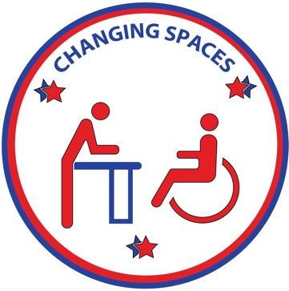
CHANGING SPACES
CAMPAIGN

Date:
Dear Representative ____/ Senator_____:
My name is ______ and I am a (parent/guardian/caregiver/friend/family member) of a (person/individual/child/loved one), who lives with a disability. We are constituents in your district. As a concerned citizen, I want to make you aware of a problem that effects our public health and safety, as well as accessibility and inclusion in our state/city.
Many children, adults, and elderly individuals with disabilities and medical complexities are not able to fully participate in our society due to a lack of restrooms with universal changing tables. Due to their disabilities, our loved ones need to wear protective disposable undergarments. While away from home, there is nowhere to change their undergarments, as they outgrew baby changing tables long ago. The options we have are: change them in the trunk of our vehicle, which exposes them in public and does not work in extreme hot, cold or rainy weather, lay them on a dirty public restroom floor to be changed, which is unclean and undignified, or do not leave home, and become isolated. None of these are options I am willing to accept. Therefore I am advocating for height-adjustable adult size/universal changing tables to be installed in public restrooms in our community. These are much more inclusive than baby changing tables as they can be used by anyone who requires this equipment, no matter their age, height, or weight.
I am working with other concerned advocates as part of the Changing Spaces Campaign. Our goal is to make our state more accessible and inclusive. We want people who require help with daily self- care to be able to experience and enjoy trips away from home without suffering the indignity of being left in a soiled diaper for an extended period of time or being changed somewhere inappropriate.
Providing inclusive changing spaces will allow this excluded population to patronize more businesses in our communities, and will encourage more travel to our state, which will be good for our economy.
We are asking for your support to pursue a legislative bill that will require Universal Changing Stations to be added into public buildings and parks in our state. Together, we can make a great impact in the lives of one of the most underserved populations.
Advocate, Changing Spaces Campaign
Phone:
Email:
www.ChangingSpacesCampaign.com

