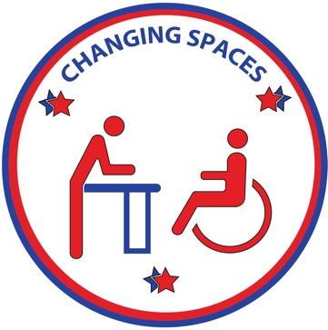
CHANGING SPACES
CAMPAIGN MASSACHUSETTS

Date:
Dear Representative ____/ Senator_____:
My name is ______ and I am a (parent/guardian/caregiver/friend/family member) of a (person/individual/child/loved one), who lives with a disability. We are constituents in your district. As a concerned citizen, I want to make you aware of a problem that affects our public health and safety, as well as accessibility and inclusion in our state/city. You can act to solve this problem by supporting Bill H.212, currently referred to the Joint Committee for Children, Families and Persons with Disabilities.
It has likely never been brought to your attention that many children, adults, and elderly individuals with disabilities and medical complexities are not able to fully participate in our society due to a lack of restrooms with universal changing tables. Due to their disabilities, our loved ones need to wear protective disposable undergarments. While away from home, there is nowhere to change their undergarments, as they outgrew baby changing tables long ago. The options at that point are: change them in the trunk of a vehicle, which exposes them in public and does not work in inclement weather; lay them on a dirty public restroom floor to be changed, which is unsanitary and undignified; or do not leave home, and become isolated. None of these are options that I am willing to accept. Therefore, I am raising awareness about the need for height-adjustable, adult size/universal changing tables to be installed in public restrooms in our community. These are much more inclusive than baby changing tables as they can be used by anyone who requires this equipment, no matter their age, height, or weight.
I am working with other concerned advocates as part of the Changing Spaces Campaign. Our goal is to make our state more accessible and inclusive. We want people who require help with daily self-care to be able to experience and enjoy trips away from home without suffering the indignity of being left in a soiled diaper for an extended period or being changed somewhere inappropriate or unsafe.
Providing inclusive changing spaces will allow this excluded population, along with their families and caretakers, to patronize more businesses in our communities and will encourage more travel to our state. Not only is this the right thing to do, but it will also be good for our economy.
We are asking you to become actively engaged on this issue, first by supporting Bill H.212. We ask you to please add your support by cosponsoring this bill and encouraging the joint committee on CFPD to pass it favorably. We also invite you to engage with the Changing Spaces Campaign in Massachusetts, which is working to find ways to make more immediate progress so that our disabled community doesn’t need to wait years before being truly welcomed into our public spaces. Together, we can make a great impact on the lives of one of the most underserved populations.
Advocate, Changing Spaces Campaign
Phone:
Email:
www.ChangingSpacesCampaign.com

