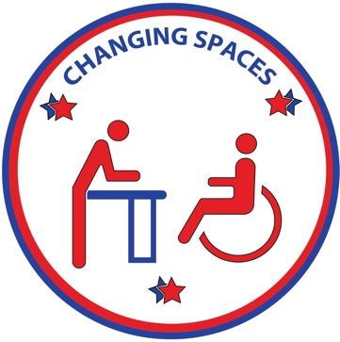
CHANGING SPACES
CAMPAIGN
Date:

Dear Business Owner:
My name is _________________________ and I am the _________of a (person/individual/child/loved one) with a disability/ I have a disability. I write to you on behalf of my ________ and the Changing Spaces Campaign. We advocate for true community inclusion for persons with disabilities.
While handicapped accessible toilets may meet the needs of some, standard disabled restrooms do not meet the needs of millions of children and adults who have the medical need to wear diapers/briefs, and have passed the weight limit to use a baby changing table. These people have no choice but to be changed on unhygienic restroom floors or in the trunk of their car in public view. Consequently, many individuals with special needs and their loved ones may not to visit your facility due to the lack of restroom accommodations.
I am asking you to consider installing a height-adjustable adult-sized changing table in your business. By adding an inclusive bathroom, you will:
1. Expand your customer base. Families will spend more time patronizing your business without the worries of meeting the toileting needs of their loved ones.
2. Promote inclusion in your business.
3. Make a great impact on the lives of individuals with disabilities, allowing them the dignity they deserve and the opportunity to be as equals amongst others in society.
4. By removing this barrier, you may qualify for tax incentives under the ADA. See https://adata.org/factsheet/quicktips-tax for more information.
Please include invite everyone to patronize your business by making this change in your restroom facilities. If there are any further questions or concerns, please contact me.
I appreciate your attention in this matter and we thank you for your time and consideration.
Sincerely,

Advocate, Changing Spaces Campaign
Phone:
Email:
www.ChangingSpacesCampaign.com

